|  |  |  |  |
| --- | --- | --- | --- |
| **NAME:** | Lauron, John Enrico D. | **DATE:** | 09/13/2023 |

ALGORITHM EXERCISE # 3.1

LE 3.11: **Weekly Pay (Pseudocode)**

START

1. PROMPTS and GETS yearly pay, yearlyPay
2. CALCULATE weekly pay by diving yearlyPay by 52, weeklyPay
3. DISPLAYS weeklyPay

END

LE 3.11: **Weekly Pay (Flowchart)**

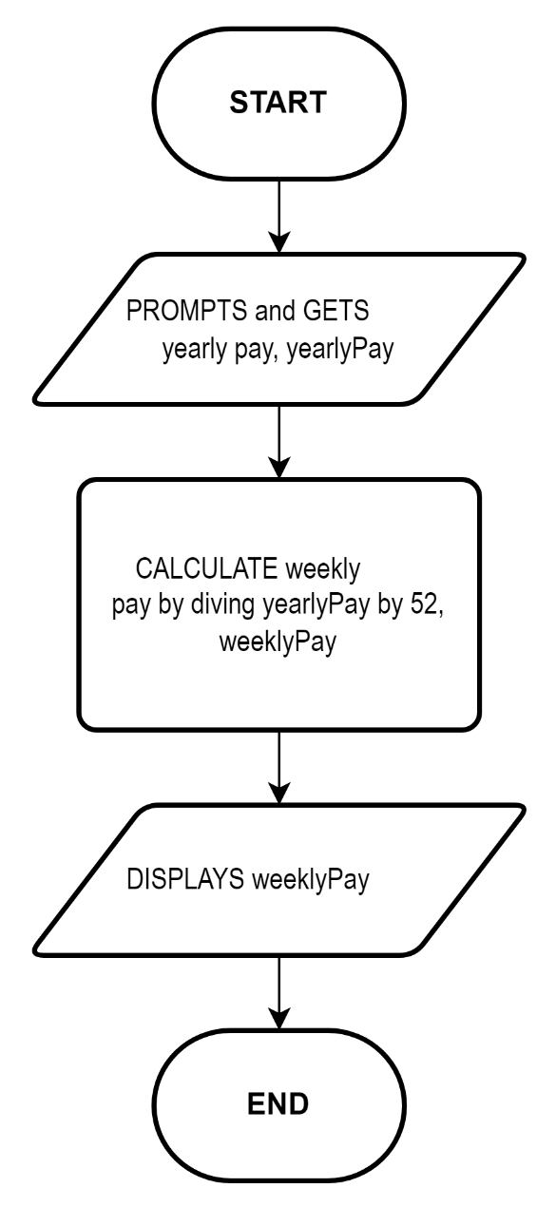

LE 3.12: **Add digits (Pseudocode)**

START

1. PROMPTS and GETS any number, anyNumber
2. GETS the last two digits from anyNumber, num1, num2
3. CALCULATE num1 and num2, sum
4. DISPLAYS sum

END

LE 3.12: **Add digits (Flowchart)**

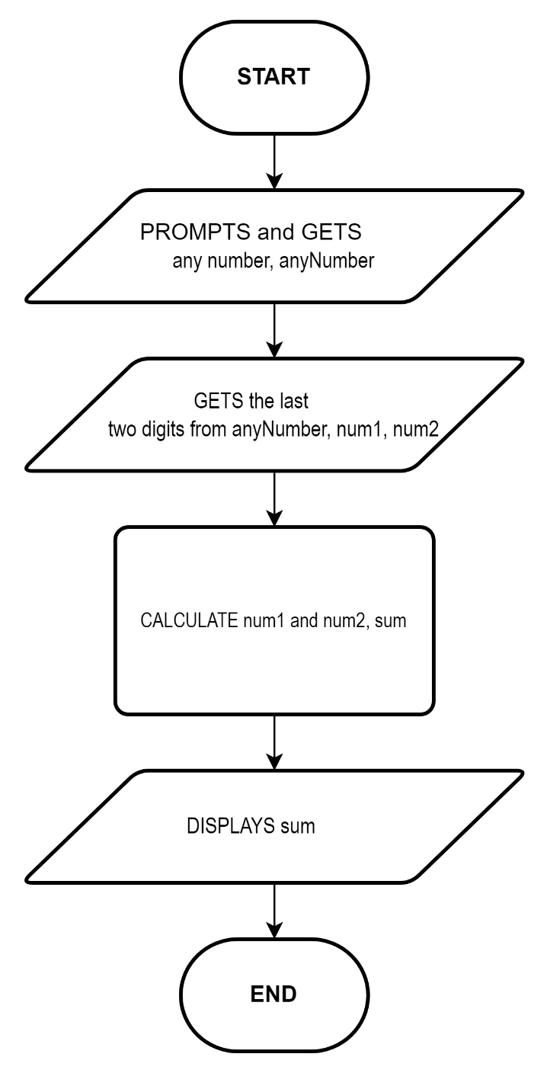

LE 3.13: **Tuition Fee (Pseudocode)**

START

1. INITIALIZE 450 as registration, registrationFee
2. INITIALIZE 450 as unit fee, unitFee
3. INITIALIZE 2260 as penalty, penalty
4. INITIALIZE 12 as penalty fraction, penaltyFraction
5. PROMPTS and GETS the number of units in the 1st semester, firstUnits
6. CALCULATE the total fee of the 1st semester firstFee = registrationFee + unitFee * firstUnits + penalty * (firstUnits / penaltyFraction), firstFee
7. PROMPTS and GETS the number of units in the 2nd semester = registrationFee + unitFee * secondUnits + penalty * (secondUnits / penaltyFraction), secondUnits
8. CALCULATE the total fee of the 2nd semester, secondFee
9. DISPLAYS firstFee
10. DISPLAYS secondFee
11. CALCULATE the sum of the firstFee and secondFee, totalFee
12. DISPLAYS Total tuition fee, totalFee

END

LE 3.13: **Tuition Fee (Flowchart)**

